AIM:

To implement the Database As a services using MongoDB Altas

STEPS:

1. First open the browser and search MongoDB Altas. Login either with your username password or through google.

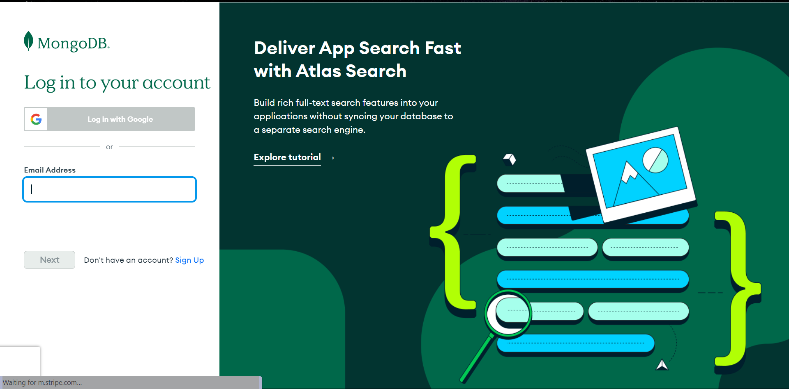

2.After Logging in you will be able to see this home page.

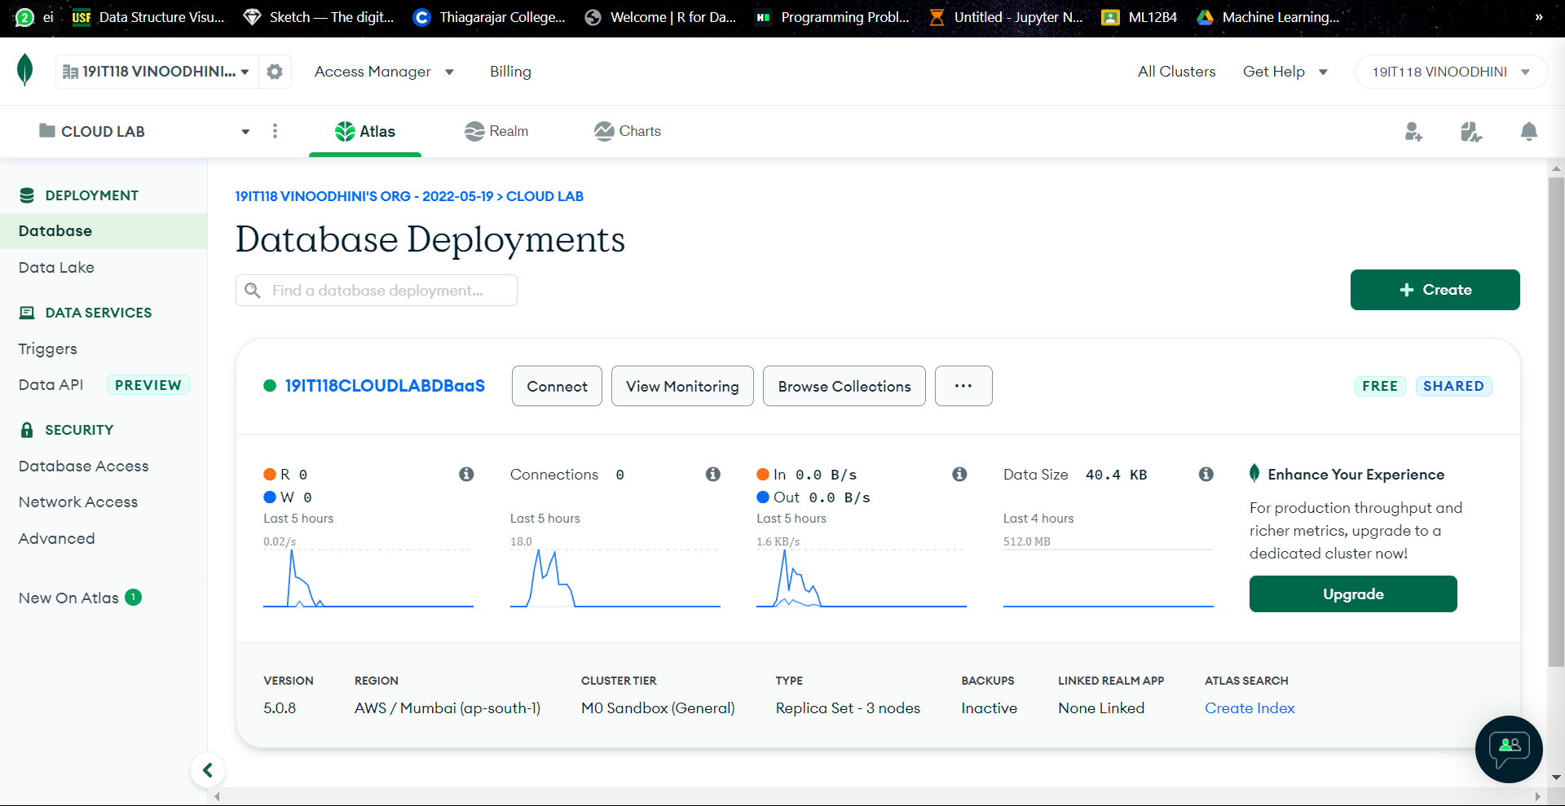

3. Create a project.

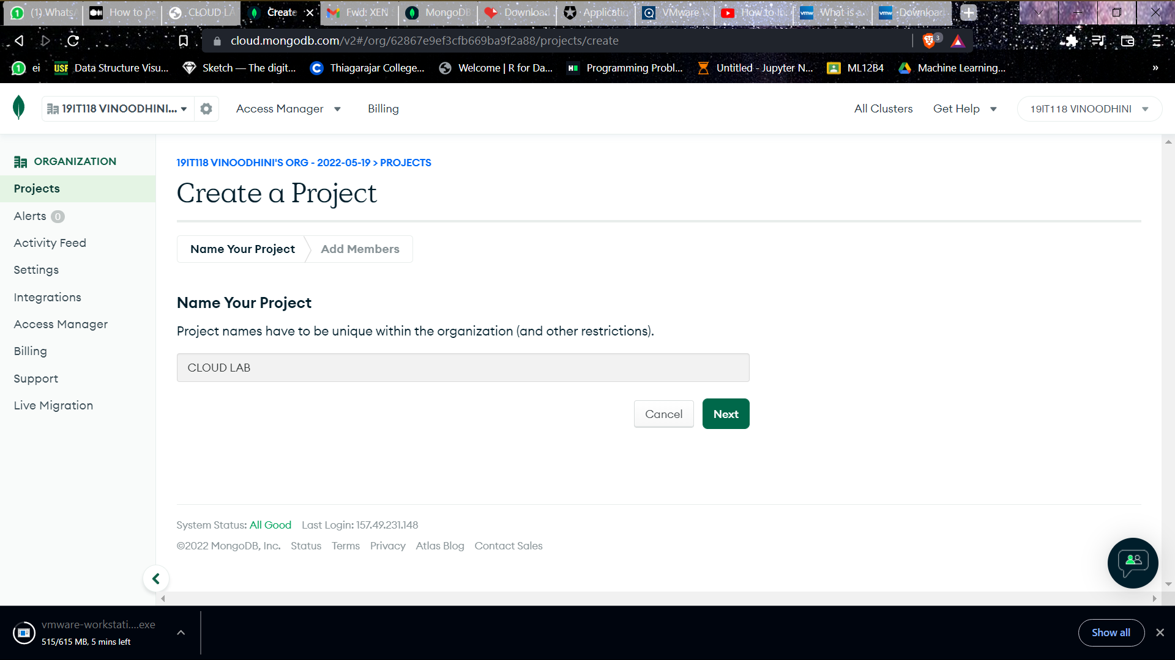

4. Add members who will be able to view your project.

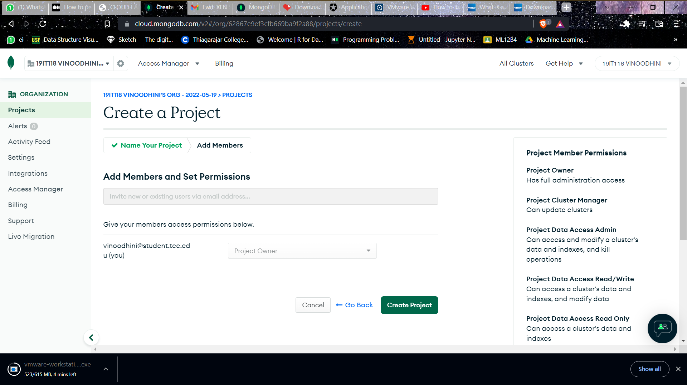

5. Now select build a database.

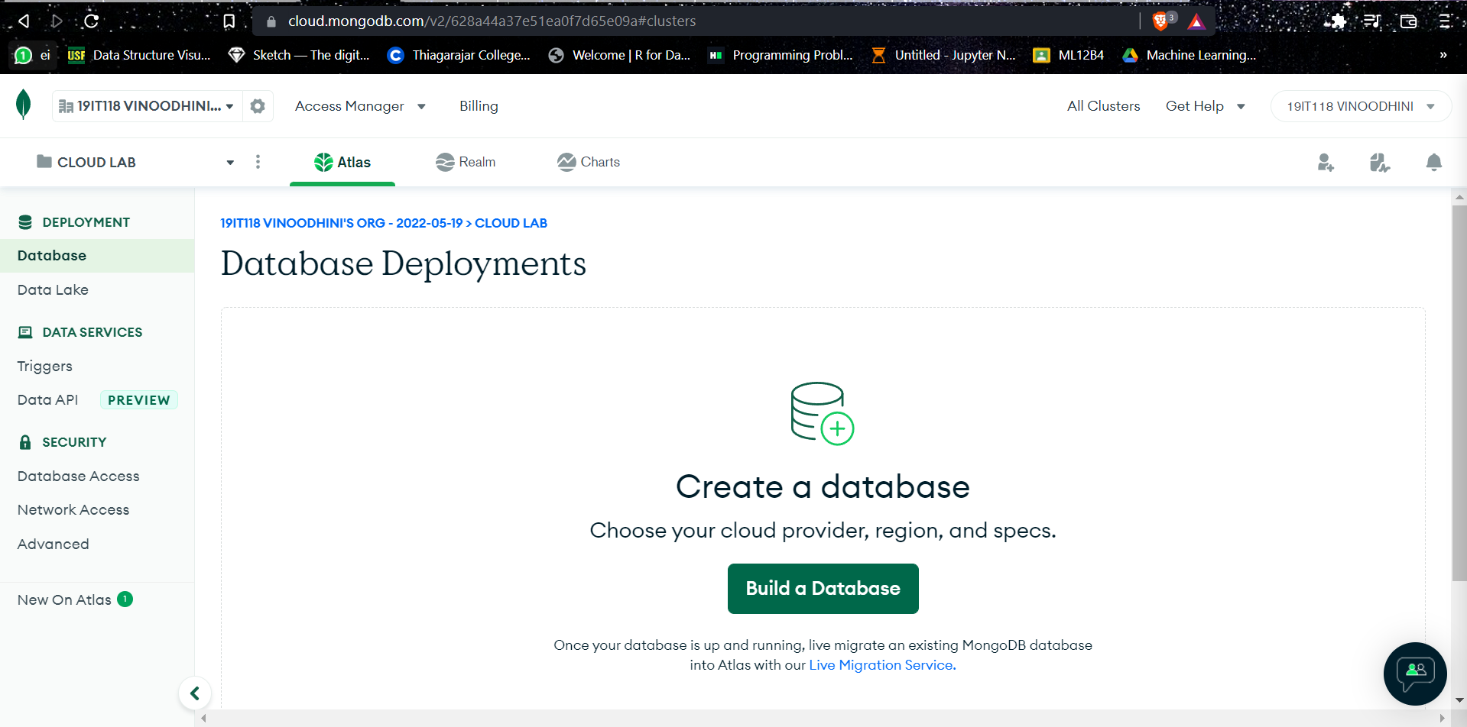

6. In this select shared database

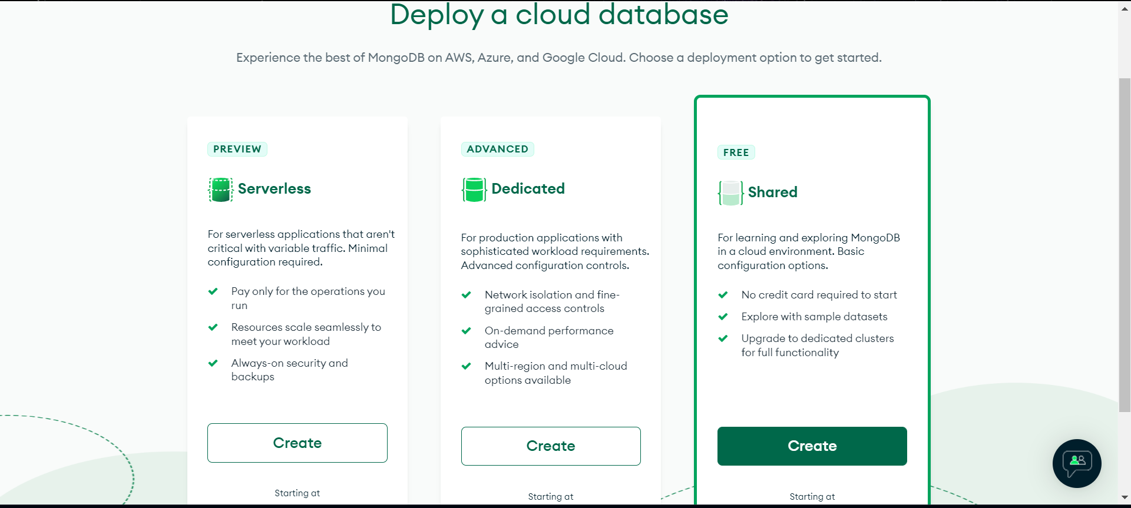

7. Here select your required region and desired cloud service provider too.

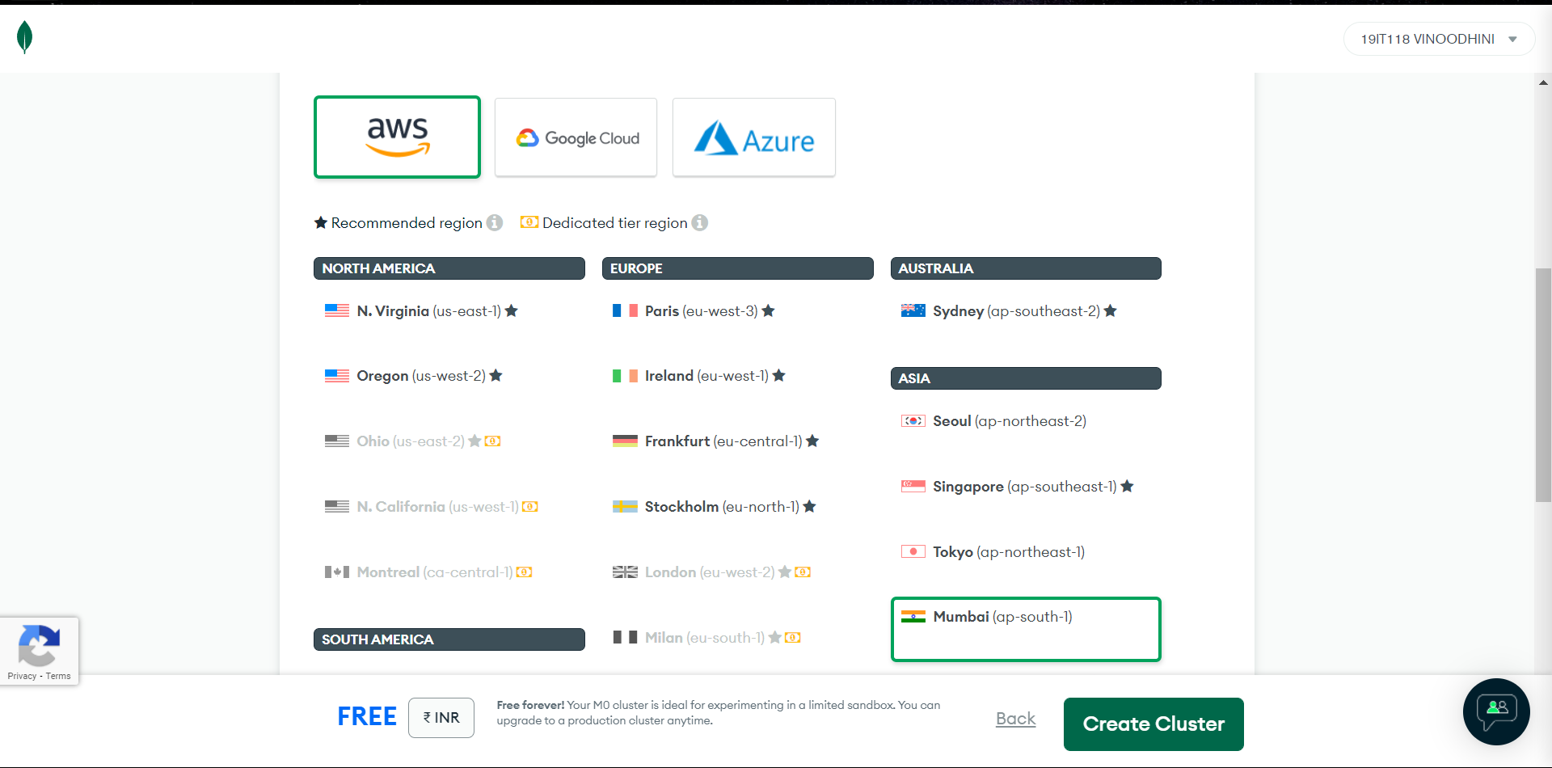

8. Select M0 SandBox for cluster Tier:

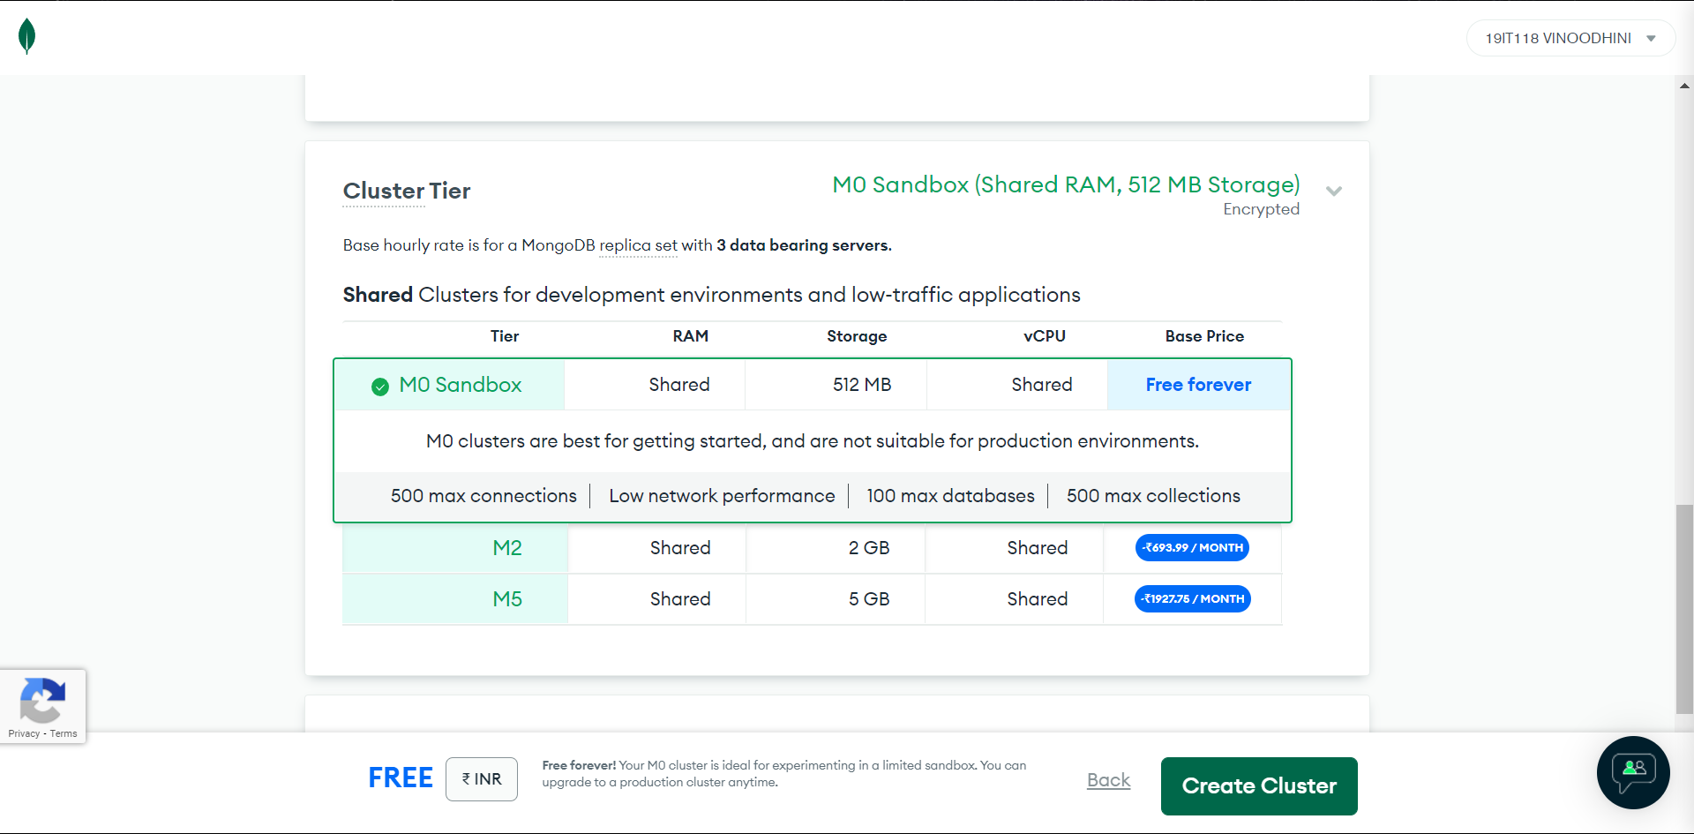

9. Name your Cluster.

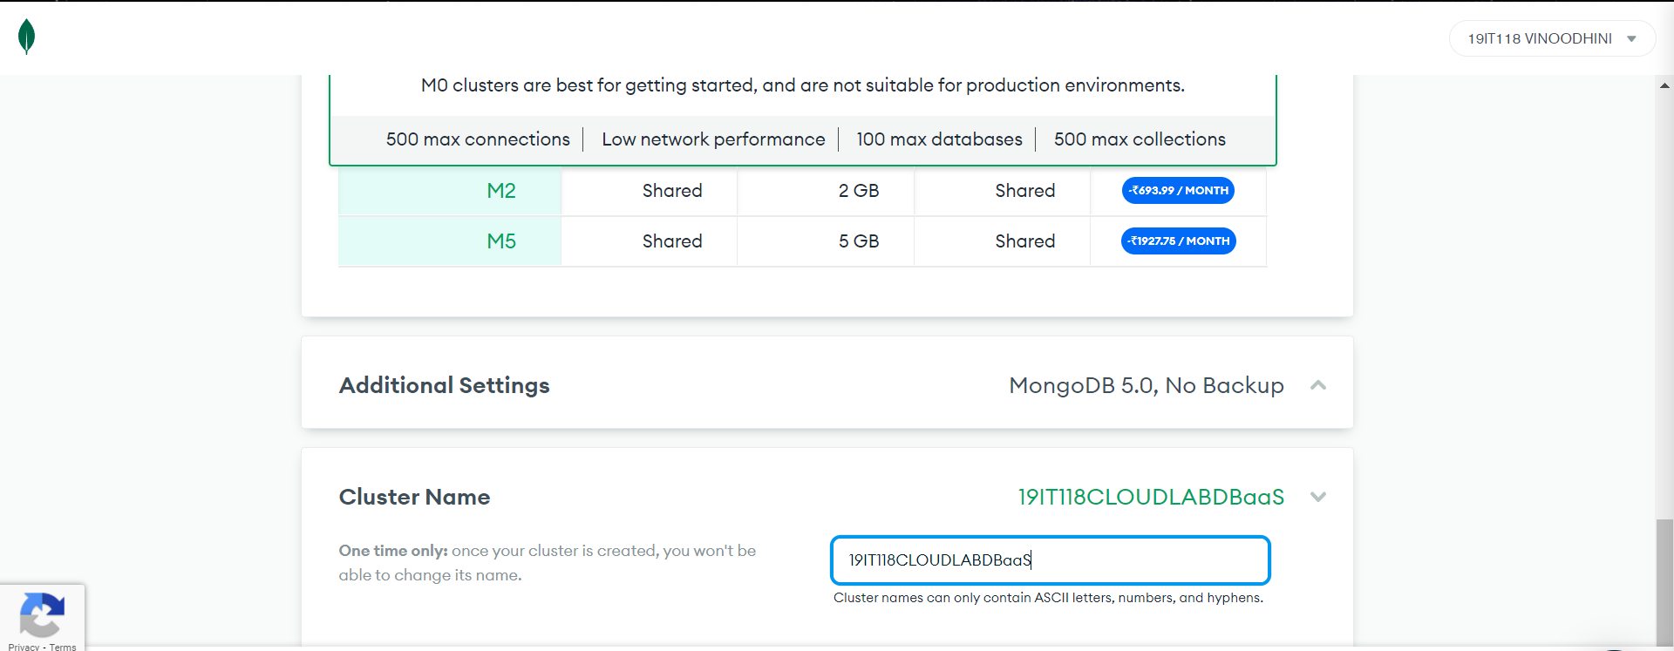

10. After creating your cluster you will be prompted to give a username and password and create an user.

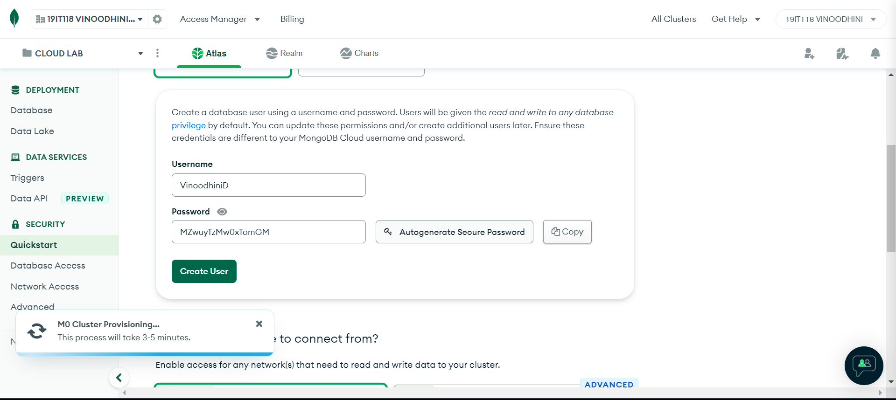

11. Enable local environment network access to your cluster and add your current IP address.

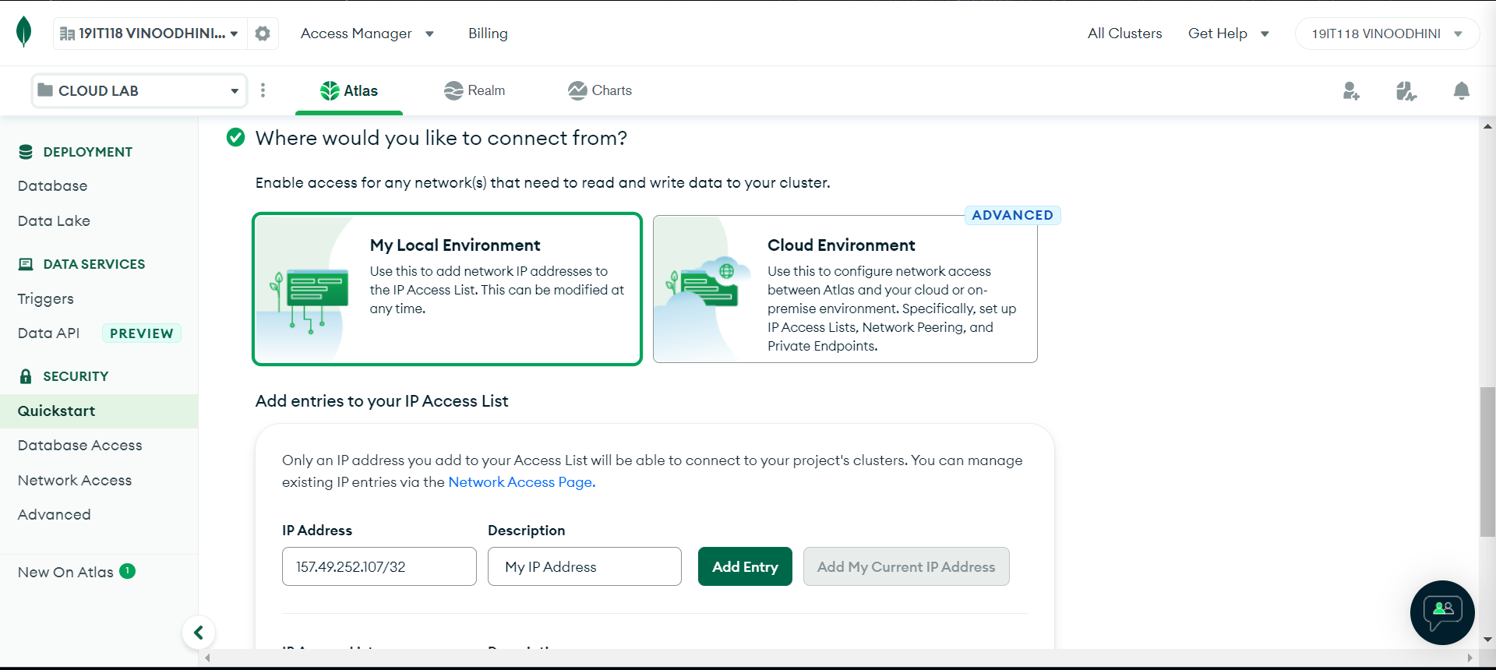

12. After creating your cluster and adding your IP address you will be able to see this screen.

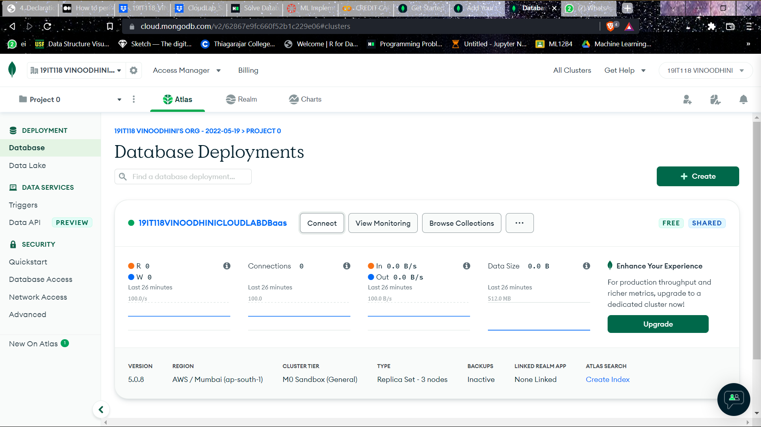

13. Now Click connect and connect using MongodbShell

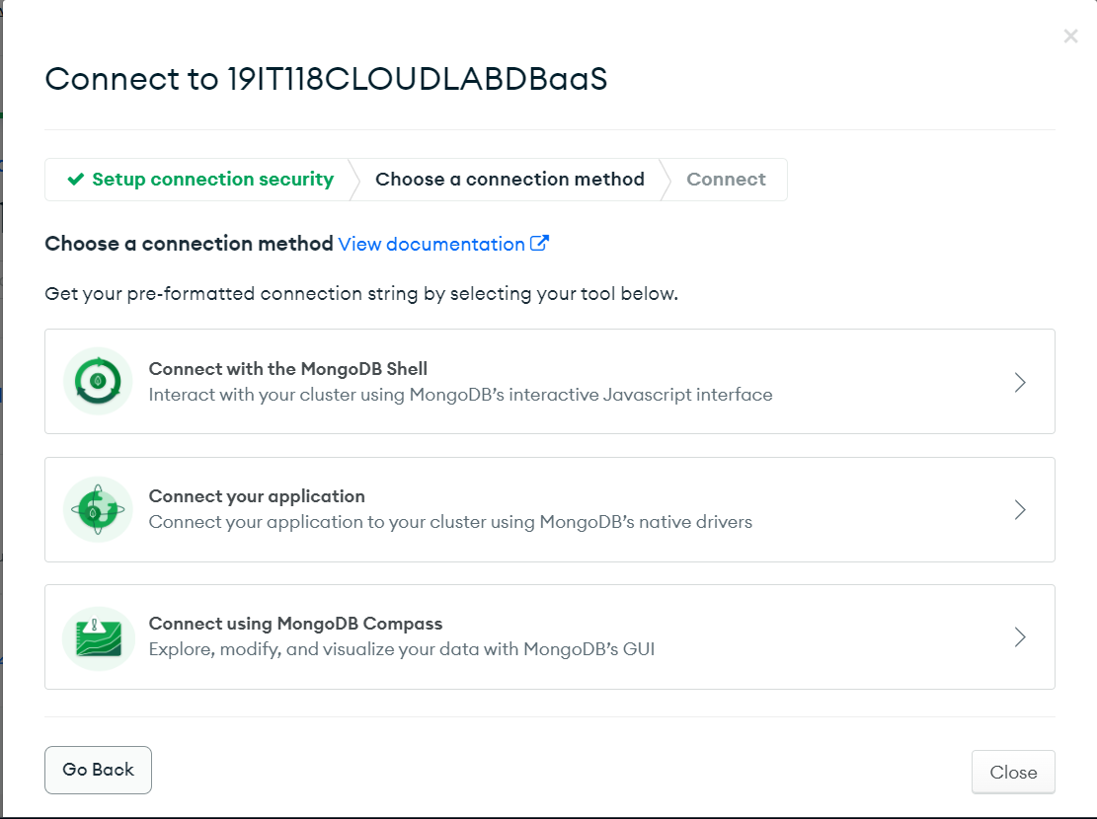

14. Download mongosh if you don’t have it.

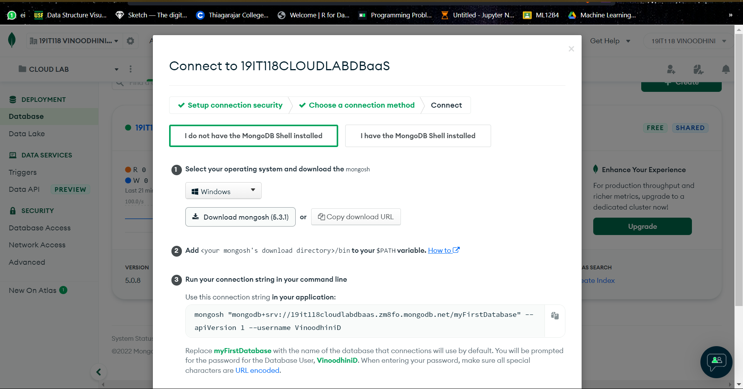

15. Once you have correctly installed and added it to your system’s path run the command **mongosh –help.**

If you get a list of options then you have correctly installed mongo shell

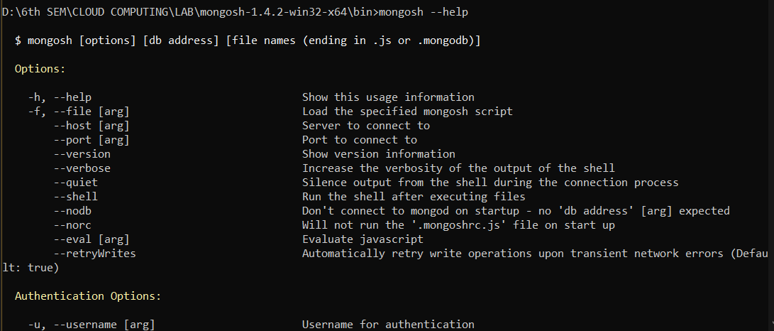

16. Now click on connect your application:

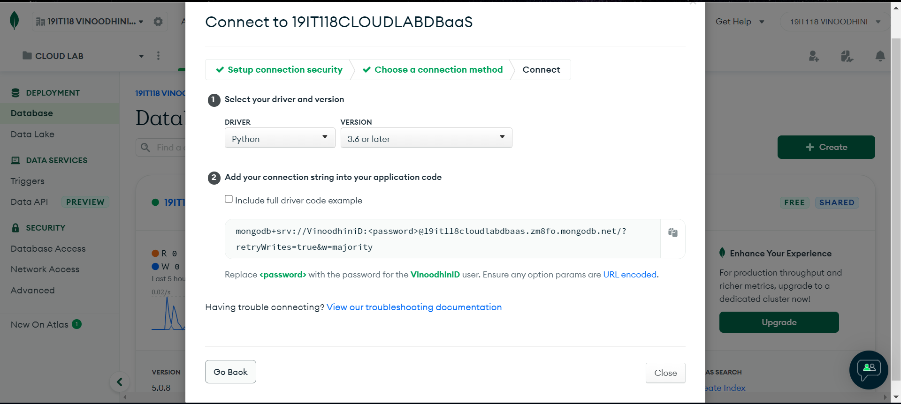

Select your desired language and copy the connection code given below.

**mongodb+srv://VinoodhiniD:<password>@19it118cloudlabdbaas.zm8fo.mongodb.net/?retryWrites=true&w=majority**

17. Connect to mongo db atlas using this command.

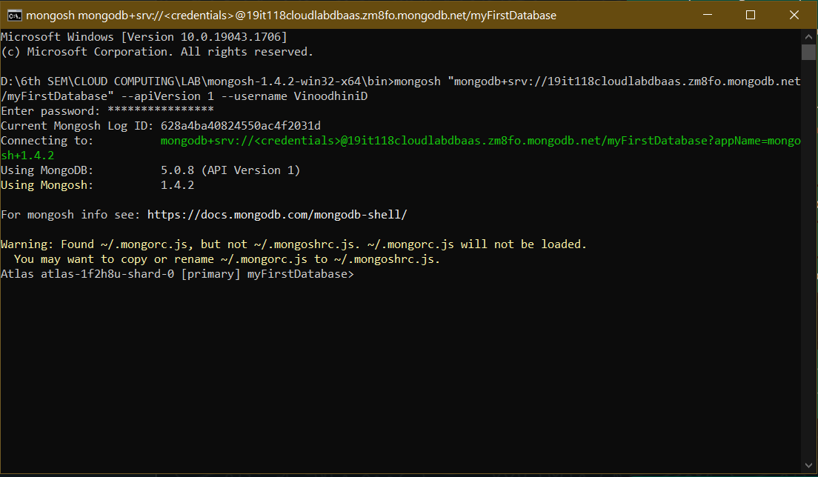

18. After this connection you just have t run the python code for creating a database inserting records updating it and and querying those records.

Installation of pymongo and dnspython

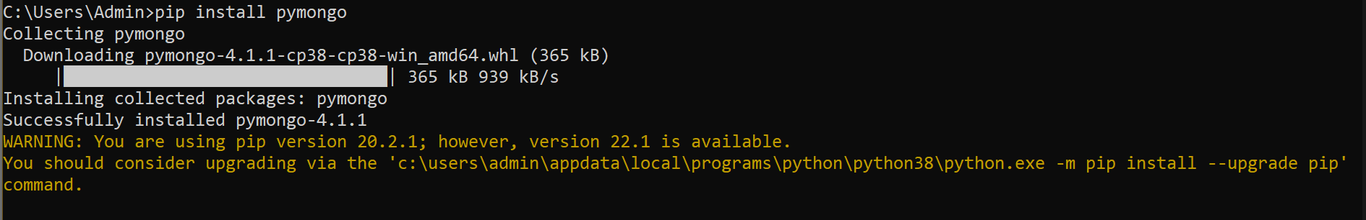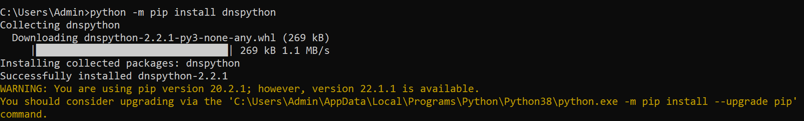

**PYTHON CODE:**

Creating a database and inserting many documents.  
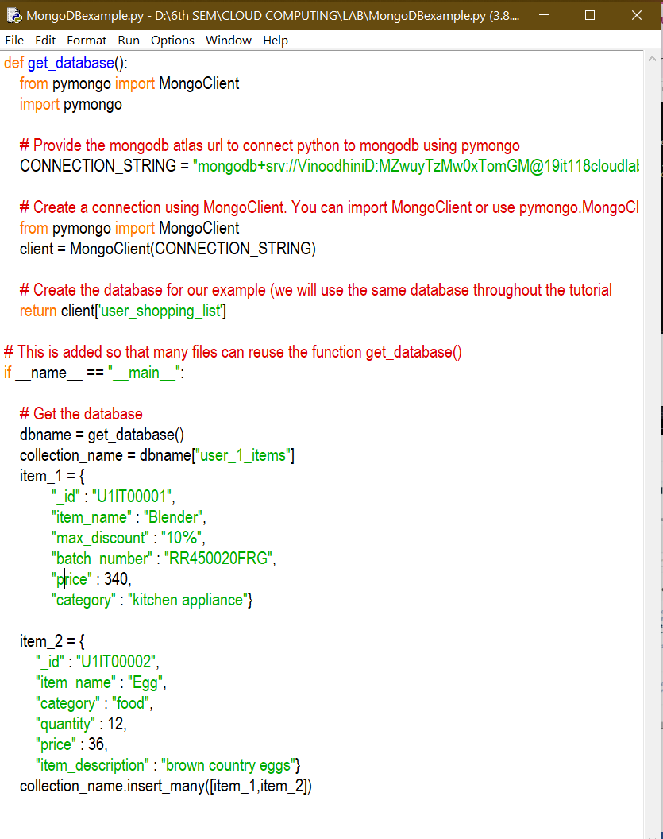

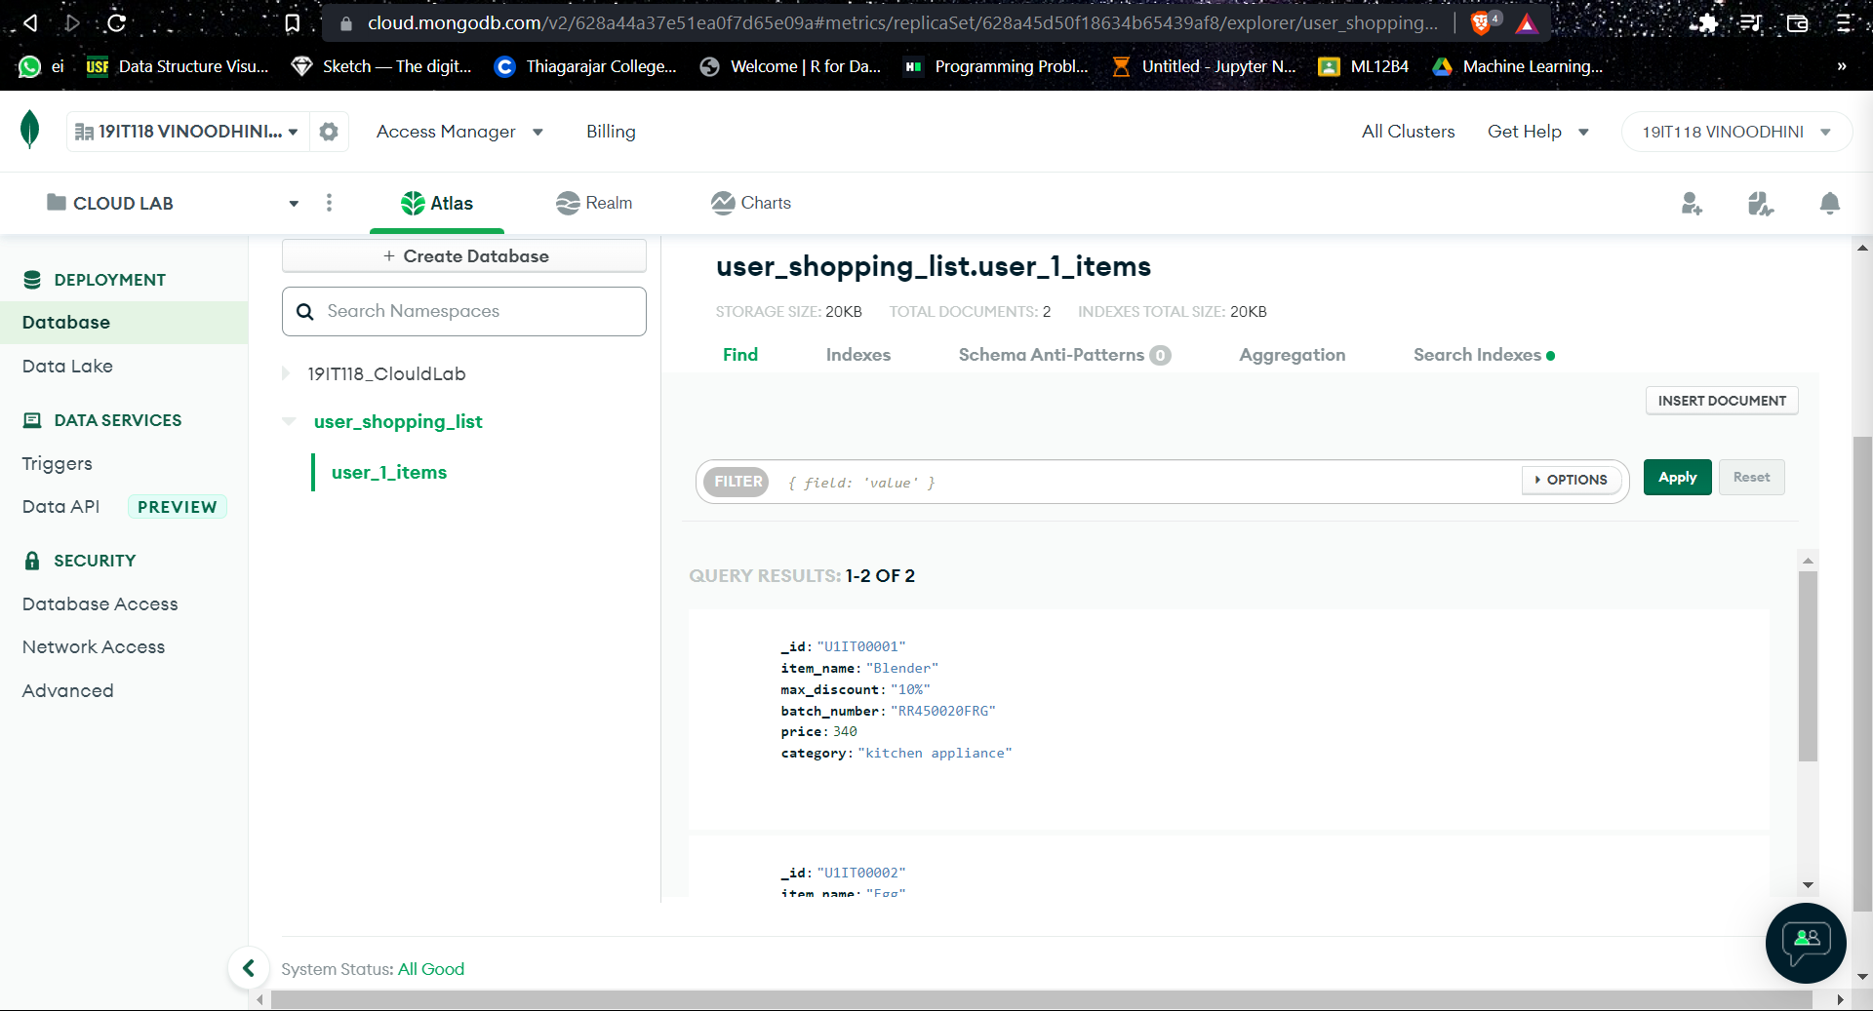

**Inserting One Document:**

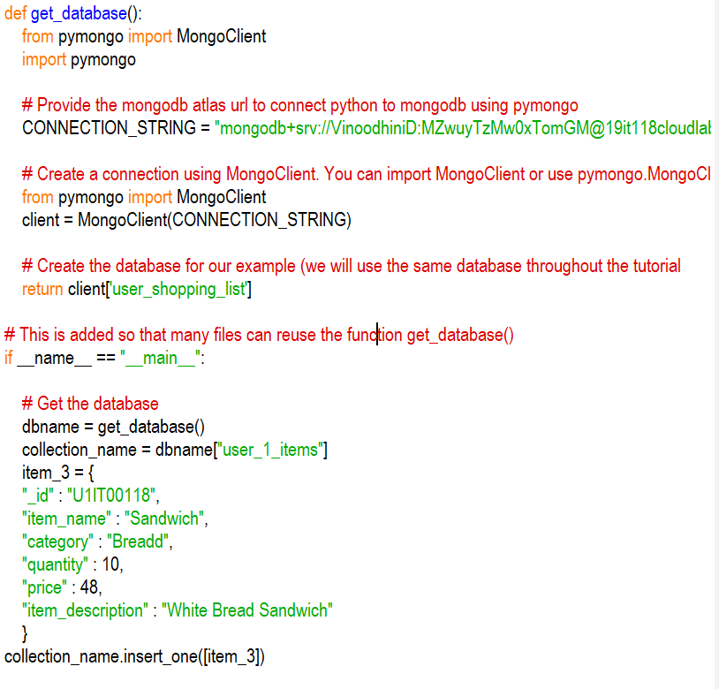

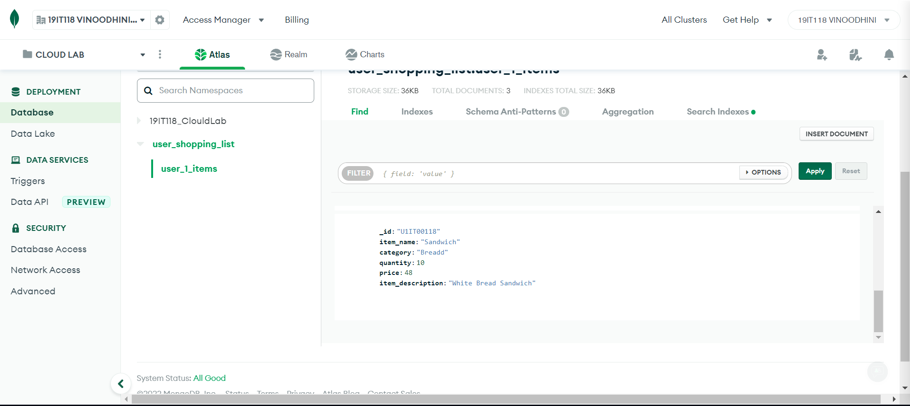

**QUERYING THE DATABASE:**

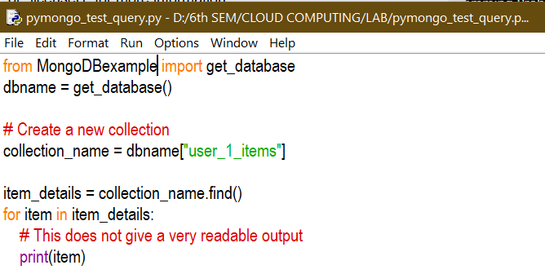

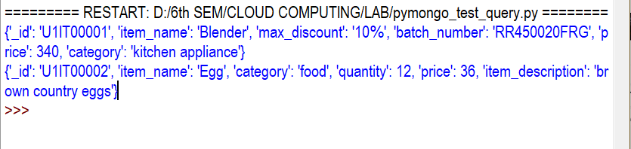

**Printing Output in a readable format:**

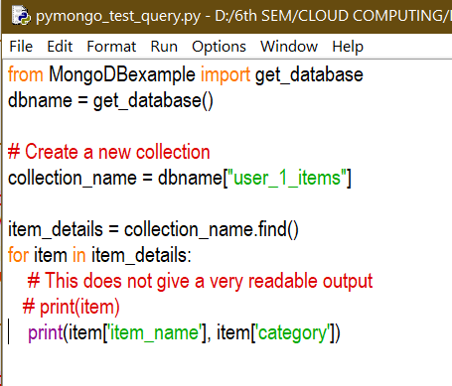

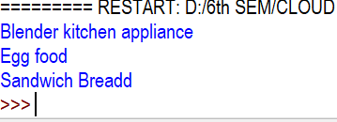

**INDEXING :**

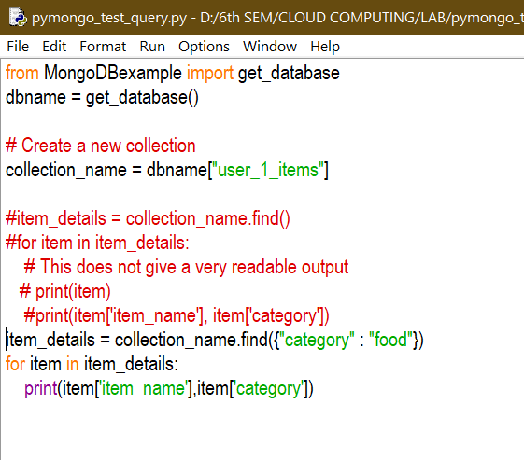



**Printing the output in a dataframe format**

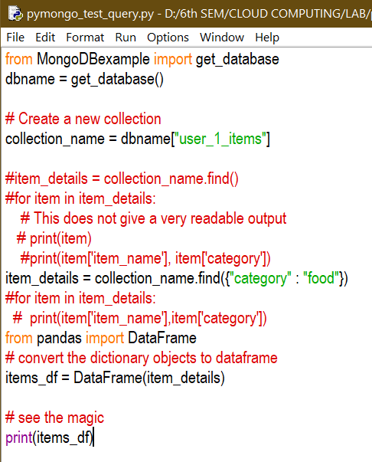

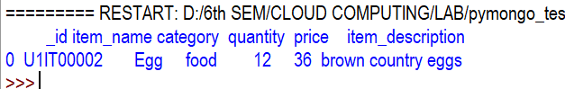

**UPDATION:**

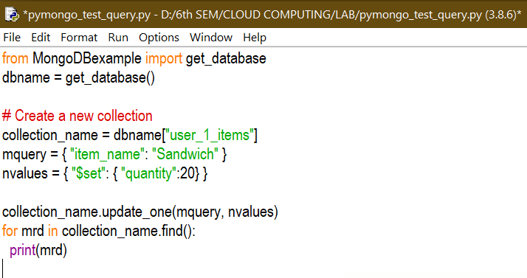

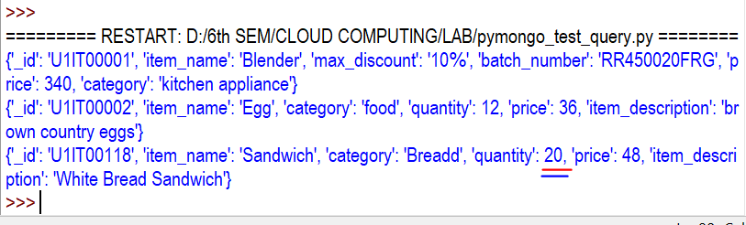

**Result:**

Thus database as a service has been implemented successfully using Mongodb atlas